

Segment Baseline Architecture
Version Number: 1.0
Version Date: <mm/dd/yyyy>

Notes to the Author

[See the FEA Segment Architecture Methodology (FSAM) (http://fsam.gov/) for more guidance and examples.]

Segment Baseline Architecture Approval

The undersigned acknowledge that they have reviewed the <Segment Name> Segment Baseline Architecture and agree with the information presented within this document. Changes to the Segment Baseline Architecture will be coordinated with, and approved by, the undersigned, or their designated representatives.

[List the individuals whose signatures are desired. Examples of such individuals are Business Owner, Solution Architect, Project Manager (if identified), and any appropriate stakeholders. Add additional lines for signature as necessary.]

Signature: |  | Date:
Print Name:
Title:
Role:

Signature: |  | Date:
Print Name:
Title:
Role:

Signature: |  | Date:
Print Name:
Title:
Role:

Revision History

This table records information regarding changes made to the document over time.

Version | Date | Organization/Point of Contact | Description of Changes
1.0 | <mm/dd/yy> | <Organization Identifier / Point-of-Contact Name> | Baseline Version

Table of Contents

1. Introduction 6
2. Business Activity Model 7
2.1 Business Function Hierarchy 8
3. Business Process Swim Lane Diagram 9
4. CRUD Matrix 10
5. Systems and Services Scoring 11
5.1 Scoring Criteria 11
5.2 System Scoring 16
5.3 Summary of System Scoring 17
6. Referenced Documents 18
7. Glossary 18
8. Acronyms 20

List of Figures

Figure 1: As-Is Business Activity Model 7
Figure 2: As-Is Business Function Hierarchy 8
Figure 3: As-Is Business Process Swim Lane Diagram 9
Figure 4: System Scoring Summary 17

List of Tables

Table 1: CRUD Matrix Results 10
Table 2: Referenced Documents 18
Table 3: Glossary 20
Table 4: List of Acronyms 20

Introduction
This document describes the Baseline Architecture which is the current ("as is") state of the agency in terms of performance, business, data, services, and technology.

The Segment Architecture deliverables are based on the Federal Enterprise Architecture (FEA) Segment Architecture Methodology (FSAM) which consists of:

- Segment Architecture Overview. This document defines the scope, mission, and other driving factors for the segment. A governance framework may be established.

- Segment Baseline Architecture. This document describes the baseline (i.e. as-is) architecture for the segment.

- Segment Target Architecture. This document describes the target (i.e. to-be) architecture for the segment.

- Segment Architecture Recommendations. This document describes the recommendations for the segment architecture. As part of the recommendations, this document highlights the gap between the baseline and target architecture.

- Segment Architecture Migration Plan. This document describes the approach and steps to migrate from the as-is state to the to-be state, thereby achieving the target architecture.

See the Segment Architecture Overview document for background information on segment architectures and how they relate to other architectures and the IT Investment Life Cycle.

Business Activity Model
Figure 1: As-Is Business Activity Model illustrates defines processes that may require process optimization and assists in determining high-level information and information security requirements.
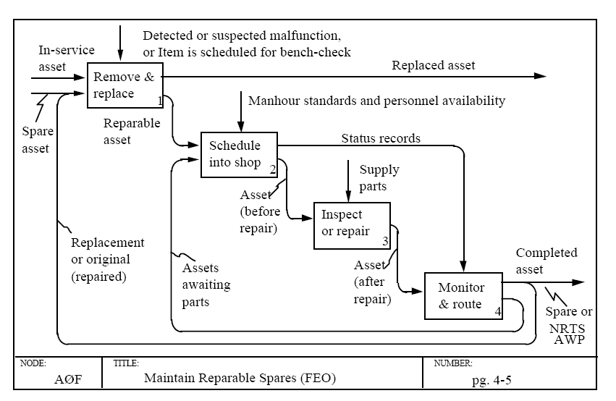
Figure 1: As-Is Business Activity Model

Business Function Hierarchy
Figure 2: As-Is Business Function Hierarchy illustrates the business functions that will be affected by potential process improvements. It also ensures that processes are analyzed in context with the correct business functions and that appropriate mappings to the FEA BRM are established.
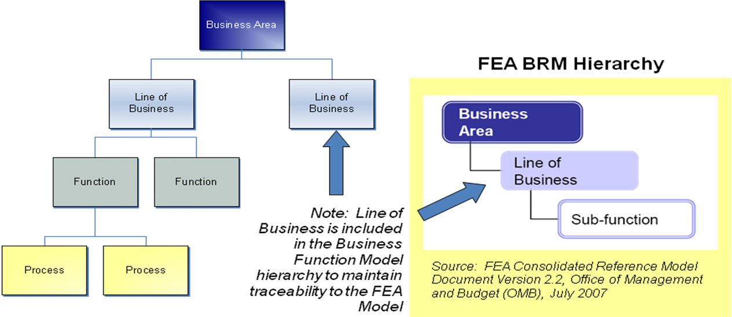
Figure 2: As-Is Business Function Hierarchy

Business Process Swim Lane Diagram
Figure 3: As-Is Business Process Swim Lane Diagram illustrates the processes that may require process optimization and assists in determining high-level information and information security requirements.

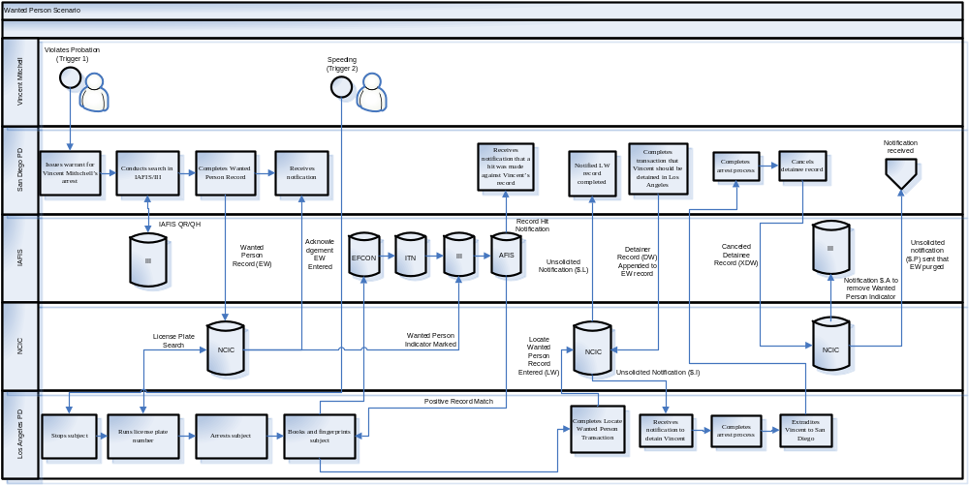
Figure 3: As-Is Business Process Swim Lane Diagram

CRUD Matrix
Table 1: CRUD Matrix Results shows the alignment of data objects and business processes to specific activities that are performed on the data object (Create, read, update, delete). The activities are performed by specific business processes captured as part of the segment, so what this matrix will show is how segment business processes affect and change specific data within the segment.
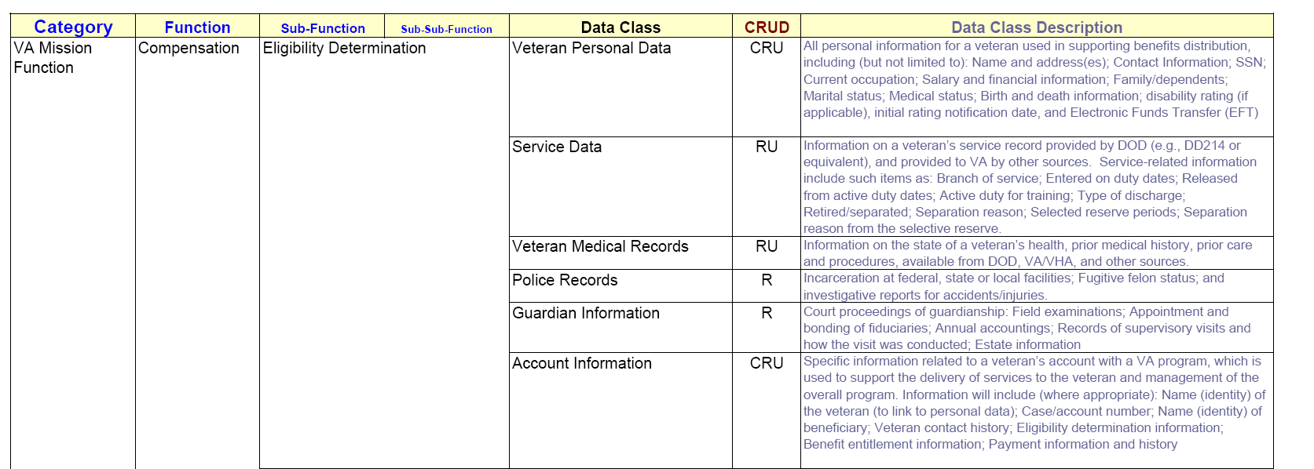
Table 1: CRUD Matrix Results

Systems and Services Scoring

Scoring Criteria
Criteria | Score Description | Reference / Target Validation | Low (1) | Medium (3) | High (5)
P1 | System’s capability for supporting associated Strategic goals and objectives as defined in DOI Strategic Plan. | Raines Rules - 1. Support core/priority mission functions that need to be performed by the Federal government. | We never really thought about this before. We know there are goals, but are not sure how or if they are supported by this system. | There are some goals that are supported by this system, but the system also does some things that the goals do not mention. | The system is designed to support the mission and the goals of the organization.
P2 | Extent of stakeholders feedback for performance measurement and system refinement. | Raines Rules - 6. Reduce risk by: establishing clear measures and accountability for project progress; and securing substantial involvement and buy-in ... from program officials who will use the system... avoiding or isolating custom-designed components ...; using fully tested pilots, simulations, and prototypes ...; | Customers? What customers? Who cares? Customers and users are never consulted as to their satisfaction with the system. No performance measurement. | System managers have a vague idea of who their customers might be (or used to be); guess about their needs and interests. Customers and users are occasionally consulted as to their satisfaction with the system. Minimal performance measures and system refinements. | Customer groups and individuals are clearly identified; their needs are documented; data collection and management systems are linked to those needs. Customers and users are regularly consulted as to their satisfaction with the system; performance is measured continuously; feedback is used to refine the system.
P3 | Demonstrate a projected return on investment that is clearly equal to or better than alternative uses of available resources (i.e. enterprise products or services). | Raines Rules - 4. Demonstrate a projected return on investment that is clearly equal to or better than alternative uses of available resources. | No business case documentation exists or no demonstrabel performance results related to ROI or ROI is now in diminishing returns state | Some business case documentation, some ROI, but ROI would required new DME costs/new capital for migration, consolidatoin, or modernization | Fairly solid business case documentation with current demonstrable ROI results as well as planned ROI
Criteria | Description |  | Low (1) | Medium (3) | High (5)
B1 | Lack of functional overlap with other systems. |  | Significant overlap between system functionality and available COTS, GOTS products, and other Org. systems. | Some overlap between system functionality and COTS, GOTS products, and other Org. systems TBA | The functionality provided by the system does not significantly overlap with other Org. systems
B2 | System incorporates re-engineered/streamlined business processes (workflow) in an automated fashion that supporting DOI Strategic goals and objectives | Raines Rules - 3. Support work processes that have been simplified or otherwise redesigned to reduce costs, improve effectiveness, and make maximum use of commercial off-the-shelf (COTS) technology. | The system was designed to match our manual processes, or we just took the systems as it was out of the box. Much workforce re-training, business process and rule customization included | There are some redeigned processes that are supported by this system, but those processes might be out of date and there are still some old processes that linger around. | There was a business process re-engineering exercise to find the best business processes for our organization. This system supports those processes.
Criteria | Description |  | Low (1) | Medium (3) | High (5)
D1 | Existence and documentation of data standards and quality control procedures. |  | Data standards are not defined, or are in a constant state of flux. No documentation exists outside of personal files and notes of the system developers to implement QA/QC systems. | Data standards are defined, but redundancies exist within a given scale. Informal and ad hoc QA/QC systems. Some documentation exists, but it is not complete nor easily accessible. | Standardized data collection protocols and data standards are fully documented and easily accessible and utilized in all data collection procedures at suitable scales. QA/QC systems are fully operational.
D2 | Relative maturity of system's data storage and access methods. |  | Data stored and maintained in proprietary databases and/or unique formats, which preclude access or use by customers. | Information systems and data structures allow data entry and exit, but it is cumbersome for users to gain access and to extract information in a usable format. | Information systems and data structures provide employees and the public ready access to current economic, social, and ecological data and information using current technology.
D3 | Relative redundancy of system data. |  | Significant overlap with other systems in terms of data elements maintained are redundant with data elements maintained by other existing systems. | Some overlap with other systems in terms of data elements maintained are redundant with data elements maintained by other existing systems. | Minimal overlap with other systems in terms of data elements maintained are redundant with data elements maintained by other existing systems.
Criteria | Description |  | Low (1) | Medium (3) | High (5)
A1 | Degree of enterprise architectural compliance | Raines Rules - 5. Be consistent with Federal, agency, and bureau information architectures which: integrate agency work processes and information flows with technology to achieve the agency's strategic goals ... and specify standards that enable information exchange and resource sharing, while retaining flexibility in the choice of suppliers and in the design of local work processes. | The system is not in alignment with the concept target architecture. No plans have been established to bring the system into closer alignment with the target architecture. | The system and its development plan are partially aligned with the organization or segment target architecture. Plans have been established to bring the system back into alignment. | The system and its development plan are aligned with the target architecture - segment and enterprise.
A2 | Extent to which system design requirements are defined and documented. | Raines Rules - 7. Be implemented in phased, successive chunks as narrow in scope and brief in duration as practicable, each of which solves a specific part of an overall mission problem and delivers a measurable net benefit independent of future chunks. | System availability, bandwidth, performance, and functional requirements are undefined and documented. System requirements not aligned with business processes. | System availability bandwidth, performance, and functional requirements are partially defined and documented. System requirements partially aligned with business processes. | System availability, bandwidth, performance, and functional requirements have been fully defined and documented and aligned with business processes.
A3 | Extent to which systems interfaces are defined and documented. |  | System interfaces, APIs, and dependencies are not defined. Not aligned with TBA. | System interfaces, APIs, and dependencies are partially defined. | System interfaces, APIs, and dependencies are fully defined.
A4 | Extent to which high-level design or operational concepts are defined. |  | No high-level design diagram or description. No operational concept documentation. | Some documentation exists, but it is not complete nor easily accessible. | High-level design and operational concept exists and is fully documented and accessible.
A5 | No alternative private sector or governmental source can efficiently support the function. | Raines Rules - 2. Be undertaken because no alternative private sector or governmental source can efficiently support the function. | Other sources do exist; enterprise licenses are already available, migration paths are easily identifiable with low risk | Other sources do exist; enterprise licenses are not already available or migration paths are identifiable but with medium risk | Oher sources may or may not exist; custom environment
Criteria | Description |  | Low (1) | Medium (3) | High (5)
T1 | Extent of compliance with Technology Reference Model standards, protocols and best practices. |  | System standards and protocols are in not aligned with those detailed in the TRM | System partially embraces TRM standards and best practices. | System embraces standards, protocols, and best practices are outlined in the TRM.
T2 | Extent of maximum use of shared, existing infrastructure components and services. |  | The system essentially creates its own infrastructure of independently procured and managed components, services and technology | The system makes some use of existing and sanctioned infrastructure components, services, and technology | The system makes maximum use of existing and sanctioned infrastructure components, services, and technology.
Criteria | Description |  | Low (1) | Medium (3) | High (5)
S1 | Extent to which the system complies with current security requirements and extent of progress through the C&A process |  | C&A has been identified as required, but C&A has not been completed or scheduled | C&A has been identified or in progress as required, but C&A has not been completed or is not up to date | C&A has been identified, is completed, and is up to date
Criteria | Description |  | Low (1) | Medium (3) | High (5)
SM1 | System deployments are modular and are/have been performed in phases based on mission needs | Raines Rules - 7. Be implemented in phased, successive chunks as narrow in scope and brief in duration as practicable, each of which solves a specific part of an overall mission problem and delivers a measurable net benefit independent of future chunks. | System was deployed specifically for this project scope; In general, deployment in one large chunk, and not modules | System was deployed for scope use across enterprises, but deployment in general in very few large modules | System was deployed for scope use across enterprises, and deployed in modules separated for business use
SM2 | Existing Acquisition and Funding Strategy is appropriate to support mission needs as an enterprise service | Raines Rules - 8. Employ an acquisition strategy that appropriately allocates risk between government and the contractor, effectively uses competition, ties contract payments to accomplishments, and takes maximum advantage of commercial technology. | Funding is setup as local contract to support sub-organization only; No acquisition concept supported for supporting new consumers in burstable manner | No Working Capital Fund exist for extending services - annual funding only; Optional extensions to support new consumers exist in burstable manner; | Working Capital Fund or similar periodic extension funding exists; Optional extensions to support new consumers exist in burstable manner;
SM3 | Existing Project/System(s) have been identified as candidate(s) for target Service needs |  | Has Never been considered as target service or has been explicitly rejected as target service prior to short list | Has been previously considered on short list as enterprise candidate | Is currently on target candidate short list or is being used as target service already

System Scoring
System/Service | Criteria | Detailed Comment | Footnote Reference
A Sys2
A Sys3
A Sys4
A Sys5
A Sys6
A Sys7
A Sys8
A Sys9
A Sys10
B Sys11
B Sys12
B Sys13
B Sys14
B Sys15
B Sys16
B Serv17
B Serv18
B Serv19
T Sys20
T Sys21
T Sys22
T Sys23
T Sys24
T Serv25
T Serv26
T Serv27
T Serv28
T Serv29
T Serv30
T Serv31

Summary of System Scoring

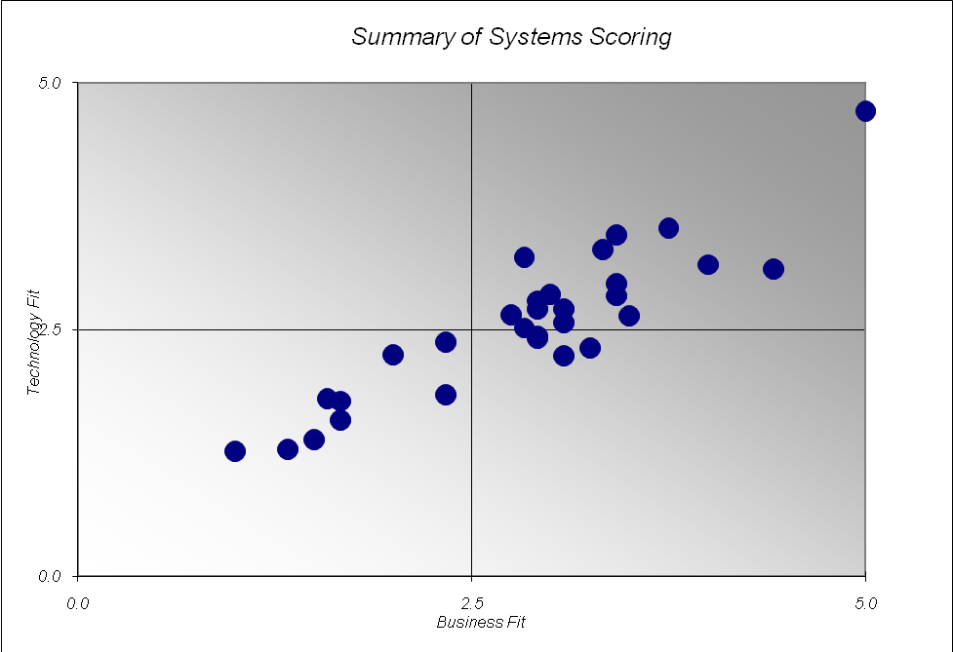

Figure 4: System Scoring Summary

Referenced Documents
Table 2: Referenced Documents lists all documents used to arrive at and/or referenced within this document (e.g., related and/or companion documents, prerequisite documents, relevant technical documentation, etc.).

Document Name | Issuance Date
 | <Month Day, Year>
Table 2: Referenced Documents

Glossary
This section defines the terms used in the document that may be unfamiliar to readers of the document.
Term Name | Definition | Source
Baseline Architecture | Describes the current ("as is") state of the agency in terms of performance, business, data, services, and technology. | FEA
Business Architecture | A functional perspective of the overall agency EA, providing information about the agency's baseline and target architectures. Examples of elements are:  - Agency business processes, aligned to business sub-functions within the FEA BRM  - Internal and external participants (roles) within these business processes  - Linkage between agency business processes and agency-specific performance measurement indicators  - Linkage between business processes to agency service components  - Agency programs, linked to business processes  - Offices and facilities. | FEA
Business Services | Defined by the agency business model, business services include the foundational mechanisms and back-office services used to achieve the purpose of the agency, e.g., inspections and auditing, direct loans, program monitoring, and financial management. | FEA
Conceptual Solution Architecture | The conceptual solution architecture defines the segment systems and services (e.g., business and information exchange) including the supporting technical and service components. | FEA
Core Mission Areas | Unique service areas that define the mission or purpose of the agency. Core mission areas are defined by the agency business model (e.g., tactical defense, air transportation, energy supply, pollution prevention and control, and emergency response). | FEA
Data Model | A data model in software engineering is an abstract model that describes how data is represented and accessed. Data models formally define data objects and relationships among data objects for a domain of interest. | FEA
Enterprise Architecture | A management practice for aligning resources to improve business performance and help agencies better execute their core missions. An EA describes the current and future state of the agency and lays out a plan for transitioning from the current state to the desired future state. | FEA
Performance Architecture | A perspective of the overall agency EA that provides information about the agency's baseline and target architectures. Examples of elements are:  - Agency strategic goals and objectives (as per the agency's Strategic Plan and IRM Plan) and linkage between performance indicators and business processes  - Agency-specific performance measurement indicators aligned to the generic measurement indicators described in the FEA PRM  - Linkage between the agency's strategic goals and investments. | FEA
Segment | Individual elements of the enterprise describing core mission areas and common or shared business services and enterprise services. Segments are defined by the enterprise architecture. | FEA
Segment Architecture | Detailed results-oriented architecture (baseline and target) and a transition strategy for a portion or segment of the enterprise. | FEA
Service | Discrete unit of functionality that can be requested (provided a set of preconditions is met), performs one or more operations (typically applying business rules and accessing a database), and returns a set of results to the requester. Completion of a service always leaves business and data integrity intact. | FEA
Solution Architecture | An architecture for an individual IT system that is part of a segment. A solution architecture is reconciled to the segment architecture above it. | FEA
Stakeholder | A person, group, organization, or system who affects or can be affected by an organization's actions. | FEA
Target Architecture | Describes the future ("to be") state of the agency in terms of performance, business, data, services, and technology. | FEA
Vision Statement | Summary description of the target business and information management environment to fulfill requirements, address change drivers, and achieve performance improvements. | FEA
Table 3: Glossary

Acronyms
This section provides a list of acronyms and associated literal translations used within the document.
Acronym | Literal Translation
EA | Enterprise Architecture
FEA | Federal Enterprise Architecture
Table 4: List of Acronyms

